# Prep Exercise (PE02) Dataframes and Modeling

### General Instructions

For this exercise you will upload this word file to blackboard. You can find the submission link by going to Weekly Content, Week 2, and then clicking on the PE02 DropBox near the lower 1/3 of your blackboard screen. Be sure to read the Homework guideline that defines what your first 3 lines of code (comments in this case) will look like.

A few highlights to pay close attention to:

* We expect that you will benefit from the code presented in Introduction to Data Science, as well as examples provided by the instructors, the Internet, and other sources. But you must always, always, always give credit to your sources. For example, if you find a line of code someone else wrote that helps you with developing a solution, by all means borrow that line of code, but make sure to use a comment to document who wrote the code. The same is true from helpful videos or tutorials from internet and YouTube.
* Questions regarding the data, code, or steps conducted within the Prep Exercise should be answered directly within this word document, attaching screenshots where necessary.

### Prep Exercise

1. **Create a new dataframe within R Studio using the ‘USArrests’ dataset (‘USArrests’ is preloaded into R Studio). ﻿**This data set contains statistics, in arrests per 100,000 residents for assault, murder, and rape in each of the 50 US states in 1973. Also given is the percent of the population living in urban areas.
   1. Creating a dataframe using a given dataset:

**myArrests <- USArrests**

1. **Verify that your new dataframe was properly populated with the USArrests dataset.**
   1. Viewing the contents of a dataframe:

**View(myArrests)**

* 1. List the attributes of the dataframe:

**Murder, Assault, UrbanPop, Rape**

* 1. Describe the instances within the dataframe:

**Each instance within the dataframe provides statistics of murder, assault, rape per 100,000 residents and percent of urban population in each of the 50 US states in 1973.**

1. **Obtain a summary of the newly created dataframe using one R Studio command. Summary of the dataframe includes Min, 1st Quartile, Median, Mean, 3rd Quartile, and Max.** 
   1. Summarize your new dataset:

**summary(myArrests)**

* 1. Place a screen shot below of the output from summary(myArrests)

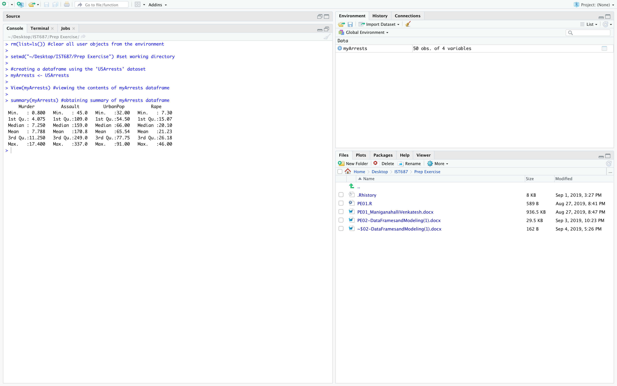

* 1. Why is the Summary command useful to a data scientist?

**The summary command helps in understanding the distribution better by providing summary statistics without the person actually performing statistical analysis. Min and max tell how stretched out the distribution is. Mean and median determine the center of the distribution. While 1st and 3rd quartile can be used for outlier detection.**

1. **Now create your own dataframe with information about your family!**
   1. Create a column of names for your family dataframe:

**myFamilyNames <- c("Mom", "Dad", "Brother", "Sister")**

* 1. Create a vector for family member ages, entering the ages in the same order that would correspond to your family members, i.e. if you entered mom first in the previous step then your mom’s age should be the first entered within the vector.

**myFamilyAges <- c("48", "52" ,"9", "20")**

* 1. Add a eye color attribute to your dataframe by defining each family members eye color in a vector:

**myFamilyEyeColor <- c("Black", "Brown", "Black", "Blue")**

* 1. Combine the vectors into a dataframe:

**myFamily <- data.frame(myFamilyNames, myFamilyAges, myFamilyEyeColor)**

* 1. Run the structure (**str()**) command on your newly created dataframe and record your observations of what the command did:

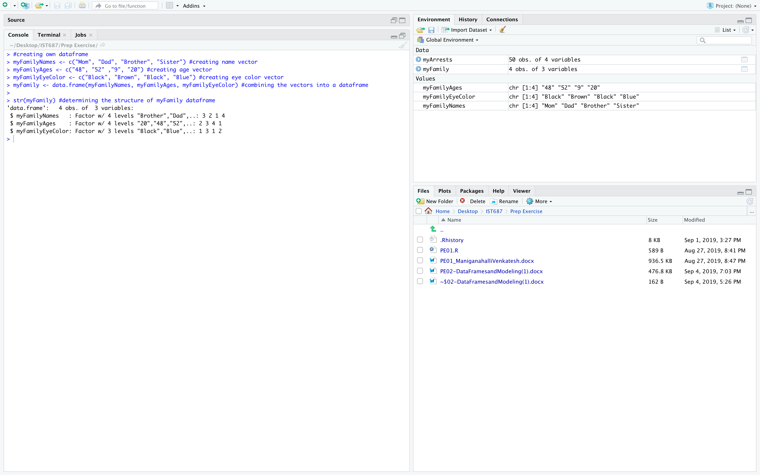

**The str command displays the dataframe name, number of observations and variables. It also displays each variable with different levels followed by few labels in alphabetic order. The numbers after semicolon are factors.**

* 1. Now run the (**View()**)command. How does the output of the View command correlate with the structurecommand?

**The view command outputs the entire dataframe in a tabular form, while the structure command gives the internal structure of the dataframe which specifies the number of observations, variables and different levels (i.e., distinct values) of the variables.**

* 1. Place a screenshot below of the output from the View() command.

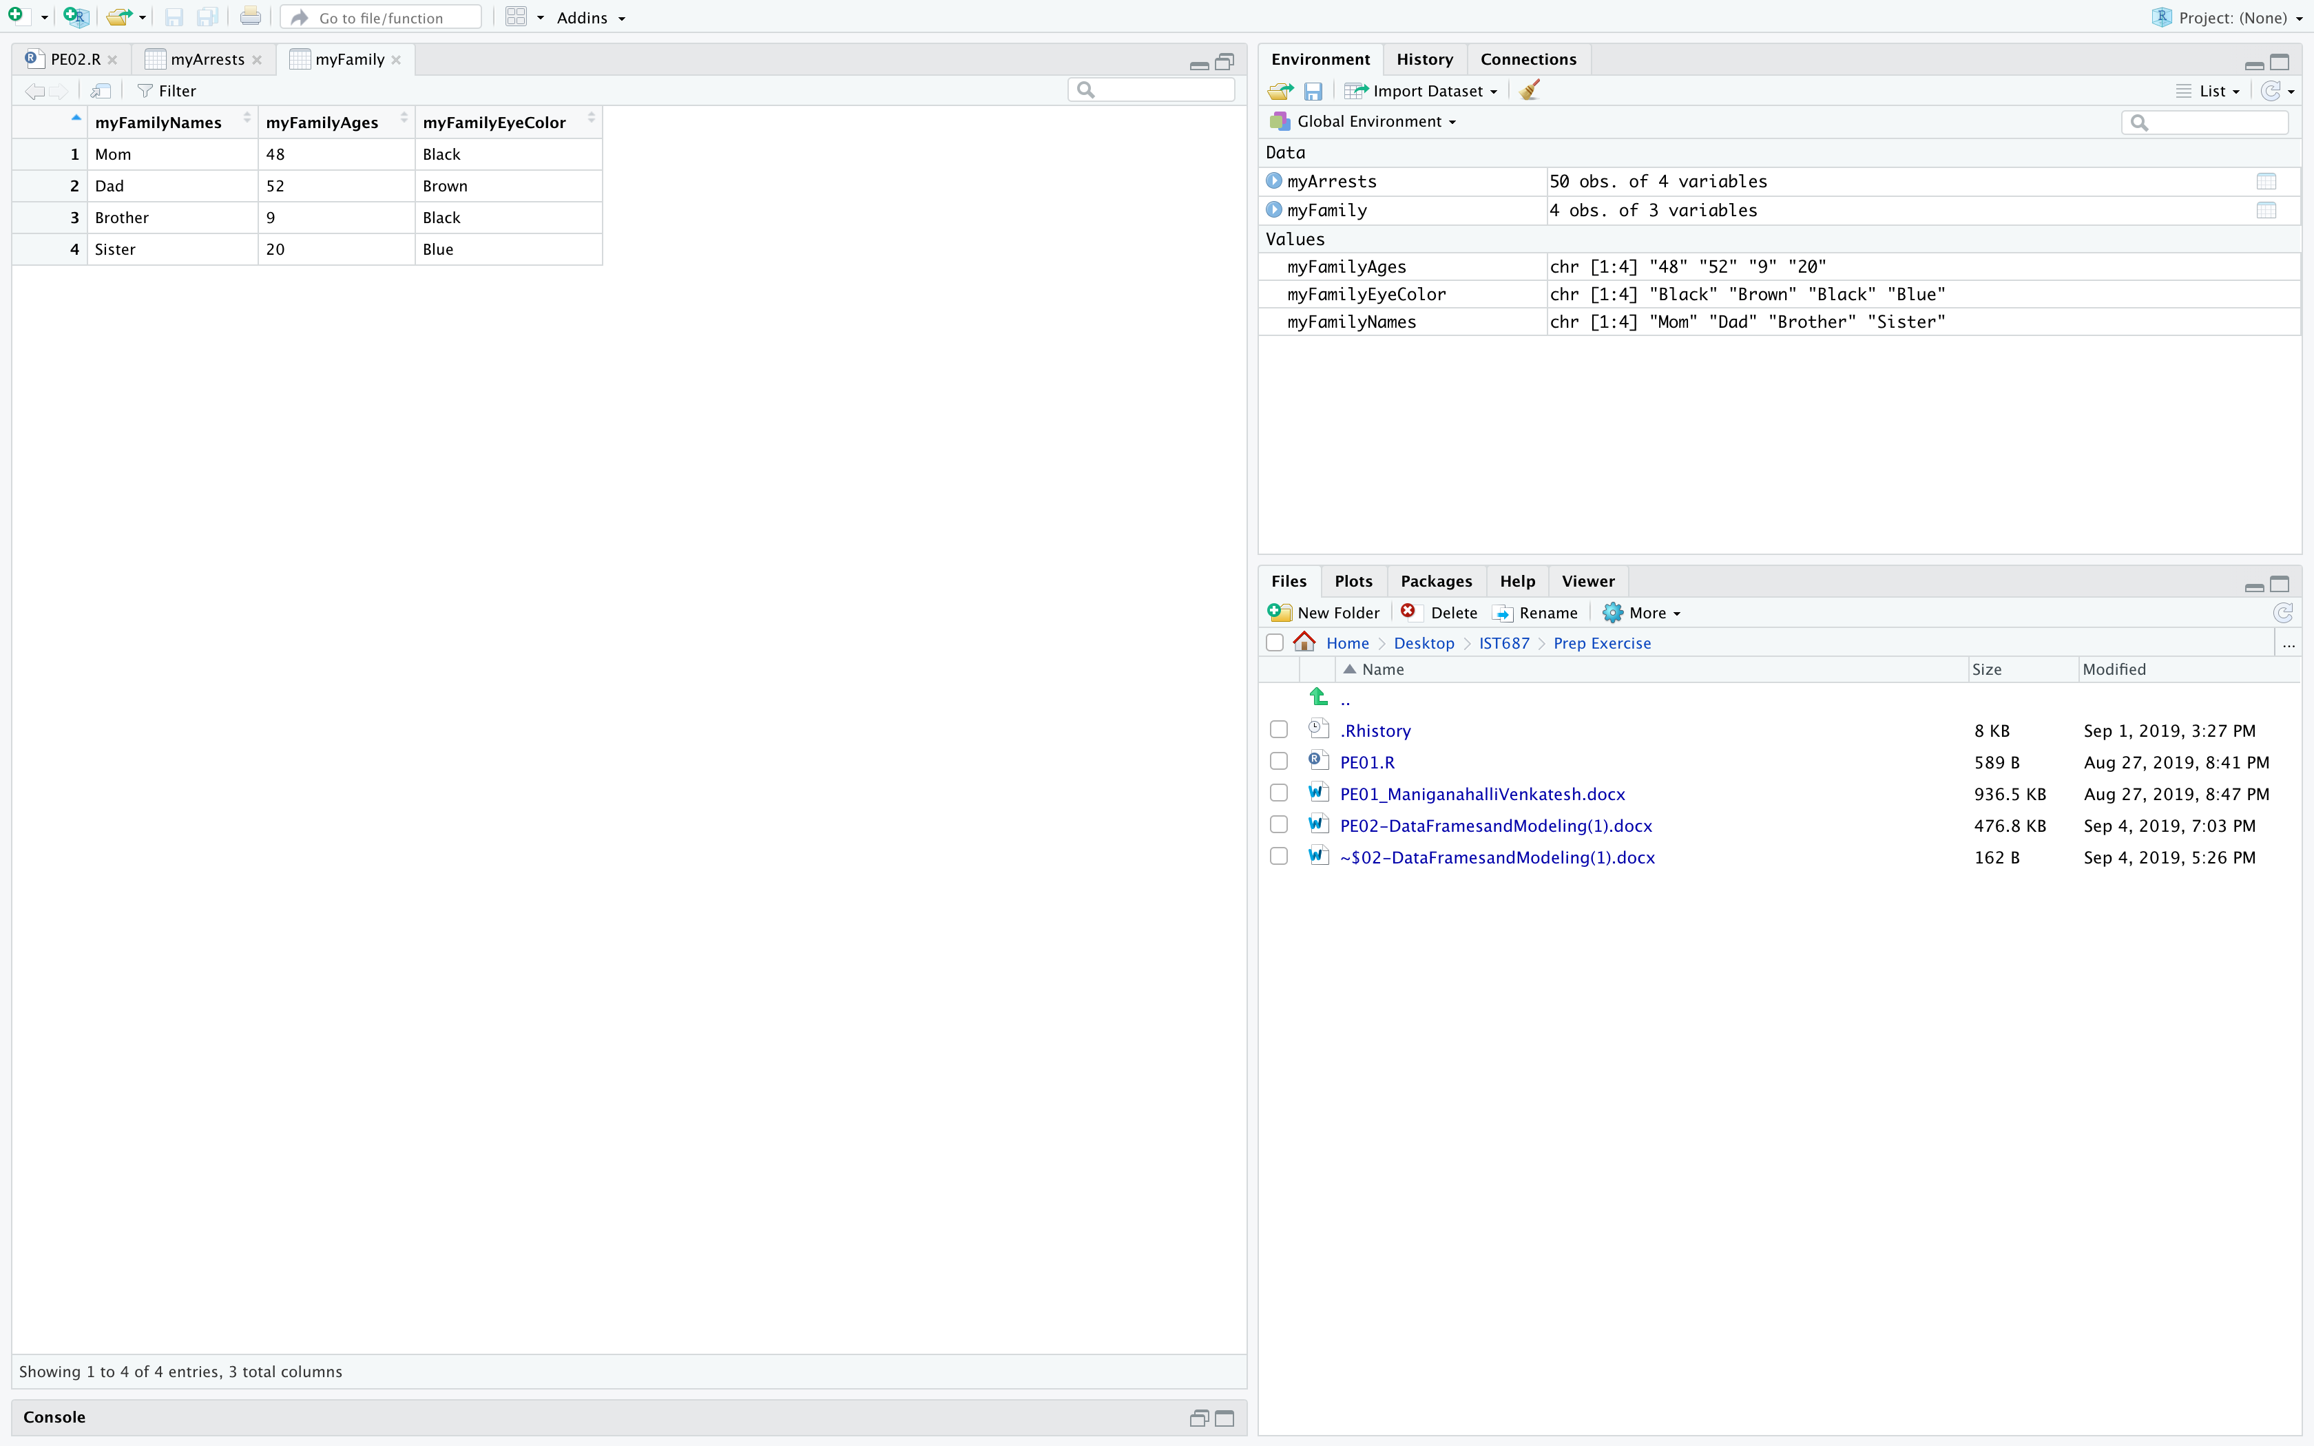

1. **Removing Rows and Columns within a dataframe.**
   1. Remove the third row in your newly created dataframe:

**myFamily <- myFamily[-3,]**

* 1. Remove the eye color column in your newly created dataframe:

**myFamily <- myFamily[,-3]**

* 1. Assuming a data scientist wishes to analyze quantitative data within the dataframe, how is removing the eye color column an example of munging?

**For quantitative analysis the eye color column (qualitative data) would be a junk and removing it will lead to a clean data set. This process of obtaining clean data set is data munging.**

* 1. Place a screenshot below of your final dataframe. (Hint: use the View() command)

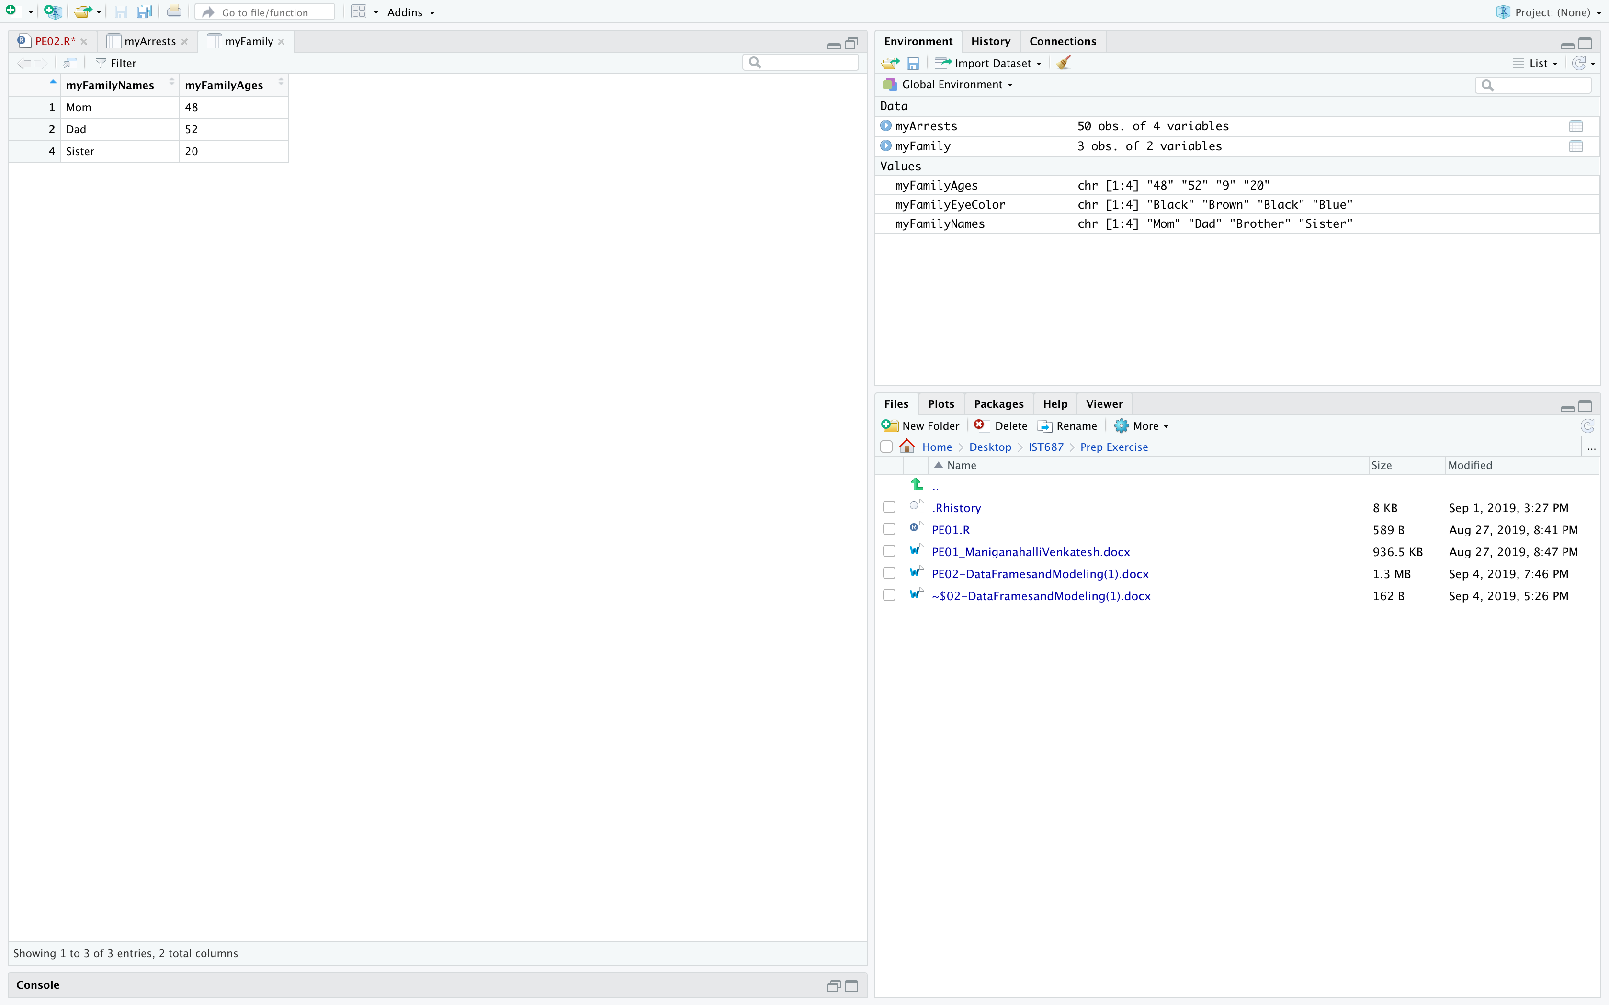

1. **List any additional resources you used here.**

An Introduction to Data Science, Jeffrey Saltz

www.rdocumentation.org

1. **Be sure to save your work as this will become the starting code for your homework.**

***You must submit all Prep Exercises to blackboard prior to the deadline specified for each assignment.*** PE assignments are due on the evening prior to the lecture class. Late PE assignments will not be accepted for credit.

*Materials provided by the instructors of this course are copyrighted 2018 by Jeffrey Saltz and Jeffrey Stanton, or by the respective instructor that produced them. These materials are provided to enrolled students for their exclusive use during the semester of instruction. Uploading instructor-produced materials to Internet sites (e.g., Coursehero) without permission is considered a breach of professional ethics and will be reported as a possible academic integrity violation.*